ITP 359, Summer 2024

Homework 6
20 points
Time series forecasting

Use a recurrent neural network to forecast a time series.
Please only submit the Python (from colab) notebook.
- Download global temperature anomaly from 1850 to the present. Temperatures should be monthly. https://www.ncei.noaa.gov/access/monitoring/climate-at-a-glance/global/time-series/globe/land/1/8/1850-2023
- Import the temperature data into a python notebook. (2)
- Set the Year column as the index. (2)
- Plot the temperature anomaly vs year. (2)
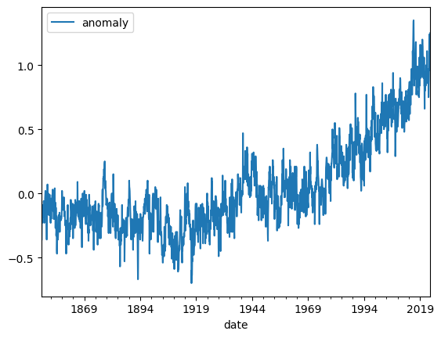
- Partition the dataset into train and test. E.g. Train partition is from 1850 to 1999. Test partition is from 2000 to 2023 (2)
- Create sequences of monthly temperatures. You may use a window of size 24.
- Build a keras RNN network.
- Train the RNN on the train partition by using sequences (use 24-month long sequences) of temperature time series. (4)
- Now forecast the temperature for 12 months in the test partition. (4)
- Plot the forecasted vs the actual temperature. (4)
